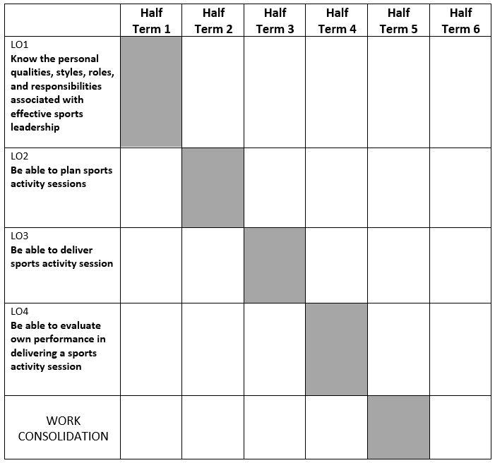

**OCR CAMBRIDGE EXTENDED CERTIFICATE IN SPORT STUDIES  
UNIT R053 – DEVELOPING LEADERSHIP SKILLs**

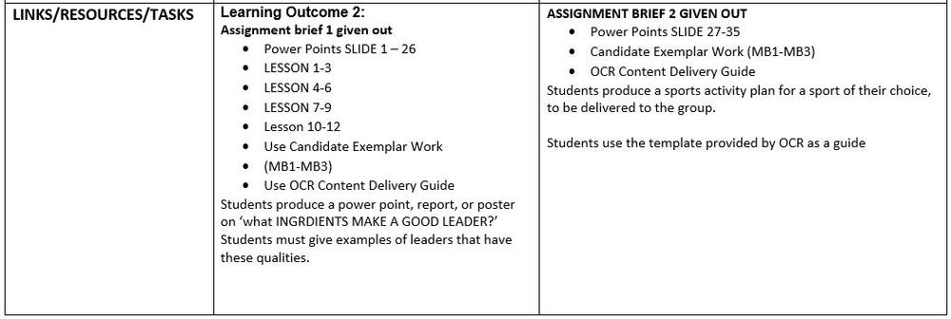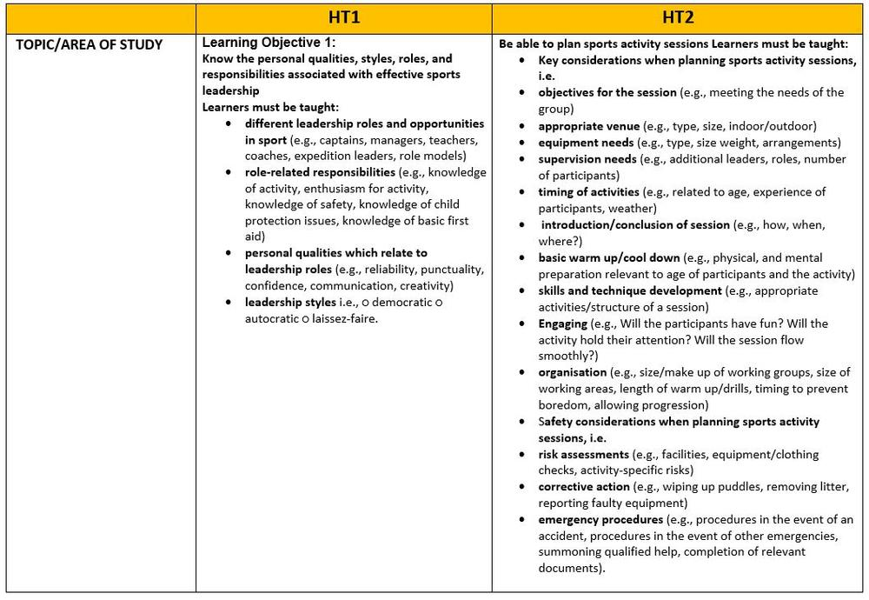

**DELIVERY PLAN – DEVELOPING LEADERSHIP SKILL**

