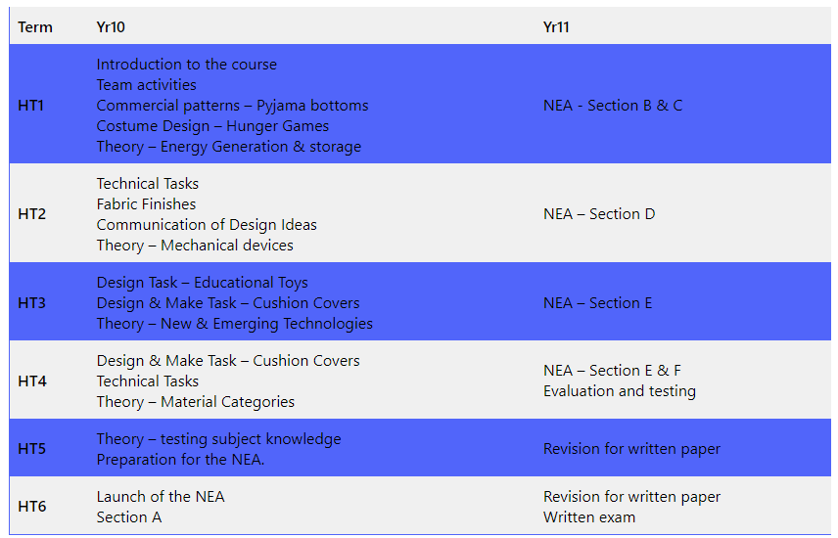
GCSE DESIGN & TECHNOLOGY – TEXTILES
Long Term Plans
